CPR Broker
PART standard

Contents
1 Overview 3
2 Operations 4
2.1 Read 4
2.2 List 4
2.3 Search 5
2.3.1 Merge 5
3 Registrations and impact periods 6
3.1 Calculation of registration date 6
4 Attributes, states and relationships 6
5 Events 6
5.1 Data structures 6
5.2 Channels 6
5.3 Notification frequency 6
5.3.1 Possible exception 6
5.4 UML Design 7
5.4.1 Registration of due events 7
5.4.2 Sending 8

Overview
This document describes a high level overview of the proposed solution. The main target of this document is to ensure a correct understanding of the project’s requirements.
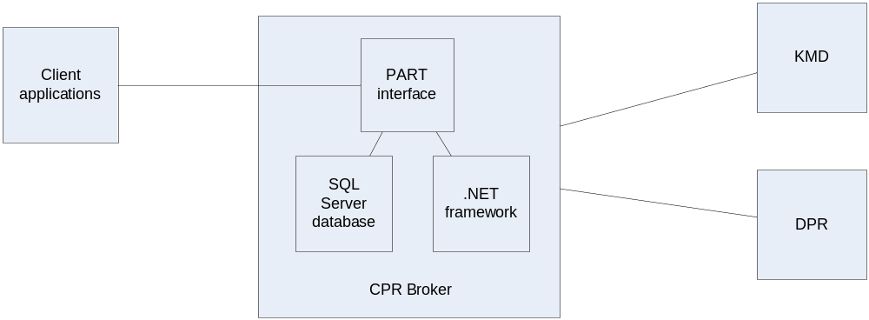
The proposed solution is to convert CPR Broker into a system that allows data exchange of persons’ data in standard PART format.

Operations
As described in the specification document, the operations are all about person data. Supported operations only include reading and searching. This is because of the nature of the broker, which is only targeted to simplify data reads.

Read
The read operation is limited to persons that have been previously loaded onto the system by means of calling Search.
The following diagram shows an overview of the process.
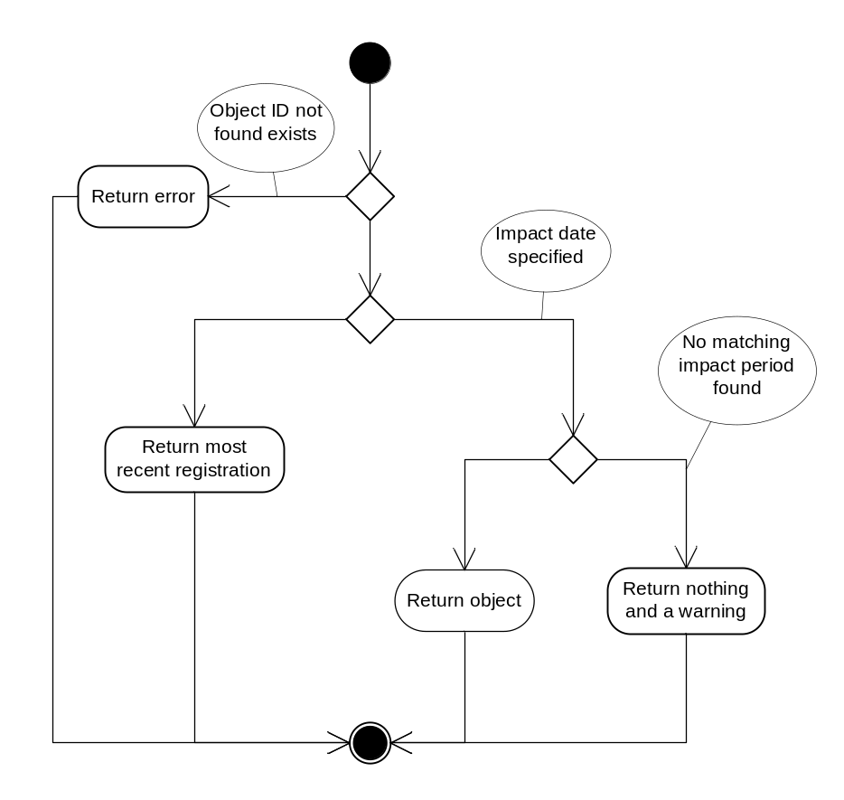

List
Similar to Read, but acts on a list of ID’s instead of a single ID.

Search
This process is where the major work is. The original implementation of CPR broker can be viewed as a simple implementation of Search operation. Actually; it is an implementation that is limited to search by CPR number.
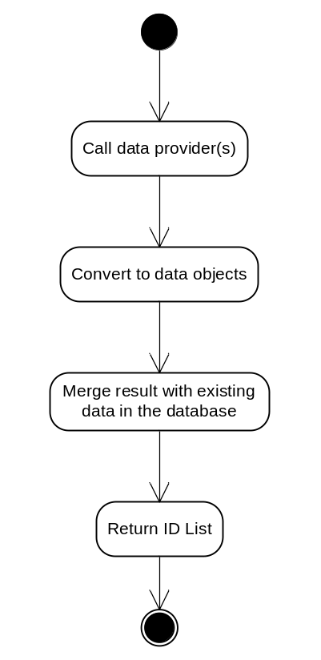

Merge
Since this is an important step in the process. When getting new data from data providers (such as DPR), it is important to correctly merge it with the database. This involves management of registrations and impact periods. A new set of data will generally be a new registration.

Registrations and impact periods
The concept of registrations will be incorporated in the solution. Each data update will be considered a registration (if needed). Registrations and impact periods should replace history tables that provide a similar functionality.

Calculation of registration date
One problem regarding this issue is that the concept of ‘registration’ may not be available in the data sources. The solution here would be to treat every change in data as a new registration. The change could be ‘getting married’ or ‘changed address’. The registration date would then be the date of one of the changes, depending on the required period date.

Attributes, states and relationships
They will be adjusted to match the new PART structure. They will be part of registrations, and will have impact periods attached to them.

Events

Data structures
Events in general will remain similar to what they are now. However, they will be adjusted to match the new data structures.

Channels
The notification channels will remain the same as current. This means XML file, Web service & GPAC channels.

Notification frequency
The nature of the data providers used in CPR broker do not show a possibility for push events. The only change that can be detected is when data is requested by a client and the fresh data is different from the version in the broker’s local cache.
An option will be added to allow for immediate notifications once a data change has been detected. The existing option of getting daily update will still be available.

Possible exception
Could there be a way to utilize the ‘Automatic update’ feature of DPR diversion so that we can get PUSH events? This is listed nowhere in the available documentation.

UML Design

Registration of due events
This is actually a part of the normal operations of the broker. Specifically, read and search operations. Whenever a new registration is made, the subscriptions are checked to see if there is any batch or immediate subscription(s) registered for the object.
If any is found, the appropriate type of notification is registered in the database for sending.
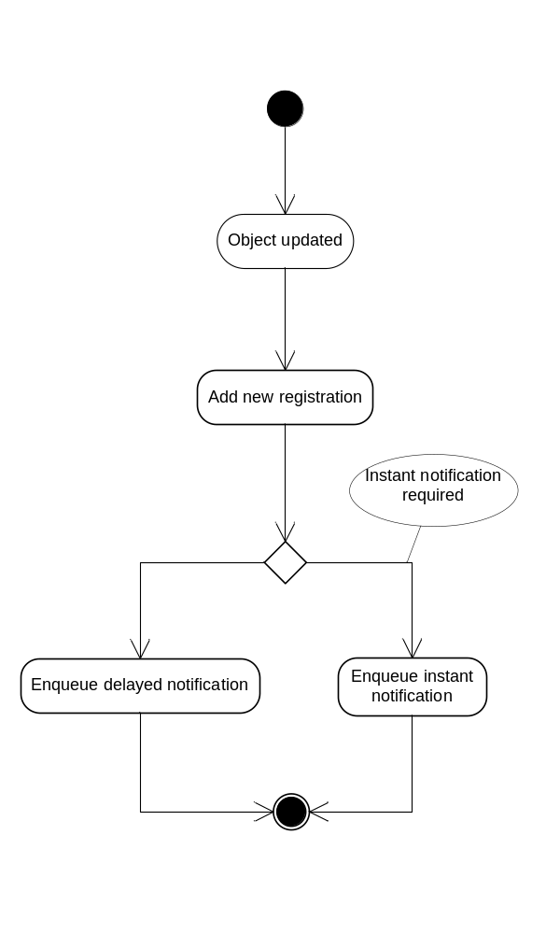

Sending
This process runs as a backend service. Every minute or so, the database is checked to see if there is something that should be sent at the moment.
If a notification is found, it is first checked to see if another notification (for the same object, with the same type and to the same channel) has been recently sent. This is the case if the same person gets more than one registration over a very short period (like a minute). If that is the case, there might be no point in sending the same notification twice. In this case, the notification is marked as ‘repeated’ and ignored. The exact definition of ‘recent’ can be anything, from one millisecond to an hour. This is to be discussed.
Now the system attempts to send the notification. If this succeeds, it is marked as ‘sent’ and it is over. If not, it is marked as ‘failed’. This means that it will be attempted later. There will be a limit to the maximum number of attempts to send a notification. There will also be a limit to the time period after which a failed notification will be ignored.
